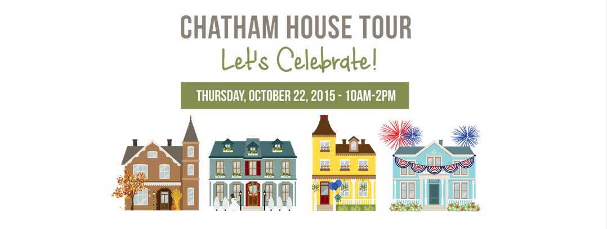
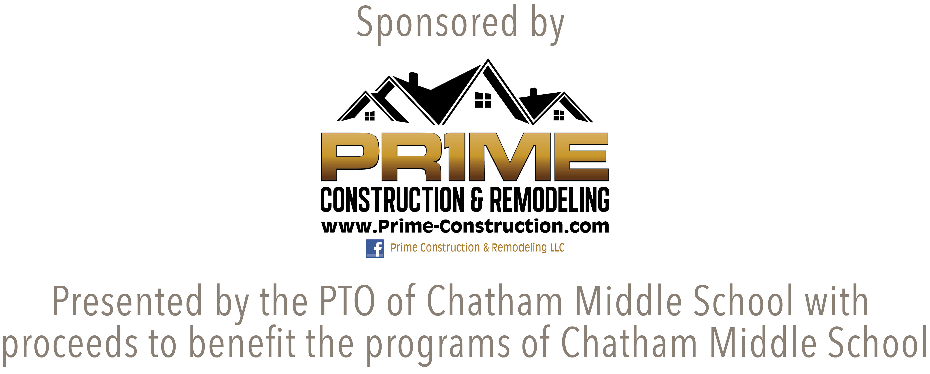

Visit 9 lovely Chatham homes featuring amazing renovations, various architectural styles and unique interior design. The houses will be staged with varied themes. Be inspired by ideas to accommodate a busy modern family or suggestions for celebrations you might like to host in your own home.

Advance tickets are $40 per person; $35 for senior citizens.

On the day of The Tour, all tickets will be $45. Tickets are non-refundable.

Visitors will retrieve tickets the day of the event beginning at 9:45 am through 12 noon. The ticket pick up location will be at Fairmount Country Club, 400 Southern Boulevard, Chatham
Please visit www.Chathamhousetour.com for more information.

Advance ticket sales are available for purchase now through October 20th online through Community Pass or by detaching and mailing form below with check payable to “CMS PTO” to CMS PTO House Tour, P.O. Box 104, Chatham, NJ 07928.

Name:

Address:

Phone: Email:

Total number of tickets:__________ Total Amount Enclosed: $_________________

For security purposes, please neatly print each ticket holders’ name:

____________________________________________________________________________________________________________________________________________________________

