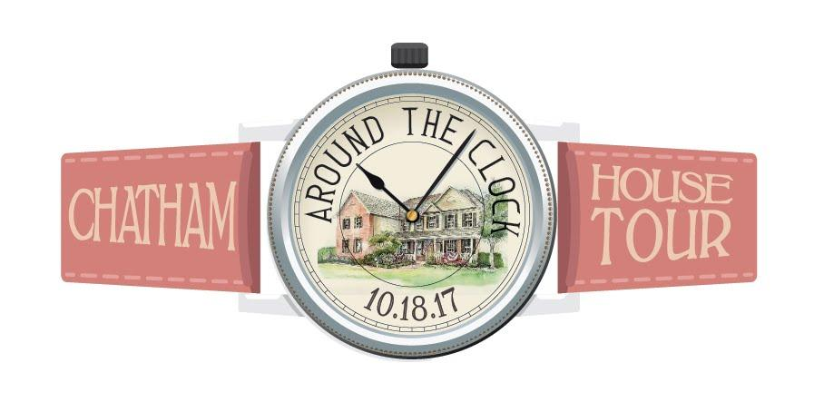
Presented by the PTO of Chatham Middle School with all proceeds to benefit the programs of CMS

Visit 9 lovely Chatham homes featuring amazing renovations, stunning architectural styles and unique interior design. The houses will be staged with varied themes. Be inspired by ideas to accommodate a busy modern family or gain suggestions for hosting celebrations in your own homes.

Online tickets are available now through October 15th via Chatham Community Pass. Advance tickets are $40 per person; $35 for senior citizens. On the day of the tour, all tickets will be $45. Tickets are non-refundable. Please visit www.Chathamhousetour.com for more details.

If you are unable to access a computer, please detach the form below, along with a check made payable to “CMS PTO”, and mail to the attention of Andrea Grom, 28 Peppermill Road, Chatham, NJ 07928 no later than October 11th.

All tickets can be picked up on October 18th at Fairmount Country Club, 400 Southern Boulevard, Chatham, NJ between 9:45am-12 noon.

Name: ____________________________________________________

Address: ___________________________________________________

Phone: ____________________________________________________

Email: _____________________________________________________

Total # of tickets: ________ Amount Enclosed: _________

For security purposes, please neatly print the name of each ticket holder below:

______________________________________________________________________________________

